HOW TO INSTALL FLEXIBLE LINDAB GUTTER / FASCIA BRACKETS (KLK)

Roof base

Depending on the roof construction of the building different types of brackets can be used. An adjustable bracket is used in the assembly instruction that follows. Other bracket applications are also shown as separate instructions. The brackets that can be used are:
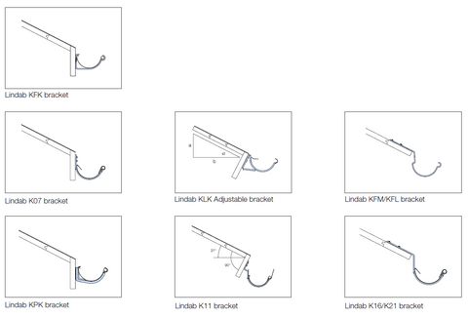

Gutter bracket assembly:
- Mark out the brackets KLK at 300mm either side of the down pipe.
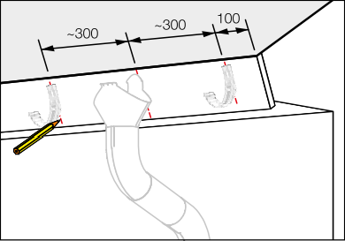

2. Fasten the “lowest bracket” 300 mm left to the down pipe mark.

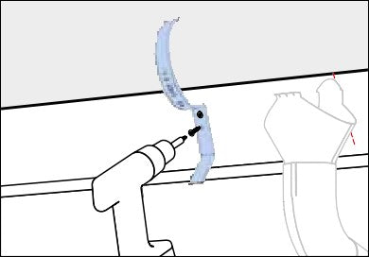

3. Fasten the bracket right of the down pipe mark 2,5 mm higher than the low bracket.
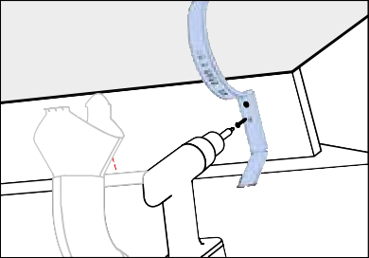

4. Fasten “high bracket” at the opposite end of roof base. The inclination to the pipe shall be 2,5 mm/m.

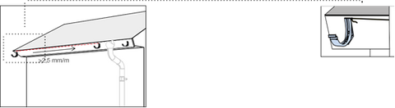

5. Stretch a string line between the highest and lowest brackets to ensure the fall is aligned and make fastening easy.

6. Fasten the other brackets with c/c 600 mm along the string.

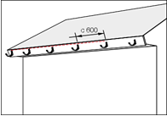

How to install the KLK Braket:

The advantage of the KLK bracket can be adjusted for different roof pitches.

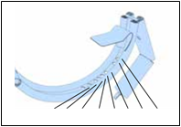

By measuring the distances in the image below you can calculate the angle of your fascia.
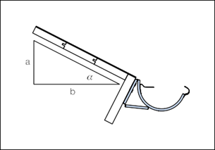
Once fixed to the fascia follow the next 3 steps to adjust to the right angle:
1.

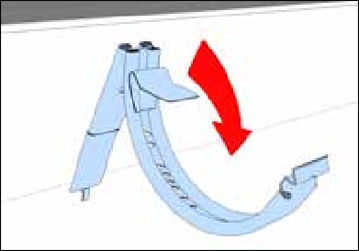
2.
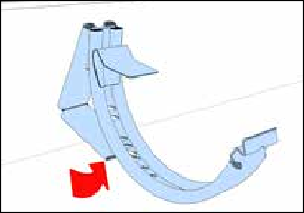
3.
